Microsoft Learning resources you can use to develop the skills necessary to succeed in the IT industry. Build your skills on Microsoft products and technologies, purchase reference books, and view course and workshop schedules to get ahead
Training and skills development are key indicators of IT team success. Organizations can now enjoy great savings on Microsoft IT Certification Exam If you plan to certify your IT team, take advantage of this offer.
Get Trained for the Job You Want! Whether you are currently unemployed, looking for a promotion, or trying to become indispensible in your existing role NPSB TRAINING SOLUTIONS provides learning paths and guidance to help you get trained for some of the top IT job roles in the industry. These learning paths focus on some of the most popular applications, such as Microsoft Windows, SQL Server, Windows Server and Exchange. To help accelerate your learning path, we are also providing Classroom training.

is delivered by using innovative Microsoft Silverlight technology and includes various media, such as animations and recorded demos.

Microsoft Certifications bring valuable, measurable rewards to students, IT professionals, their managers, and the organizations that employ them. These certifications are designed to provide the recognition you need to help you excel in your career and provide employers with validation of your skills.

Microsoft Certifications are available for most Microsoft technologies and all skill levels. Achieving a Microsoft Certification helps provide you with relevant skills that can lead you to a fulfilling career, while giving you access to valuable Microsoft Certification Program benefits. These benefits include access to the member site and a vast, global network of other certified professionals.
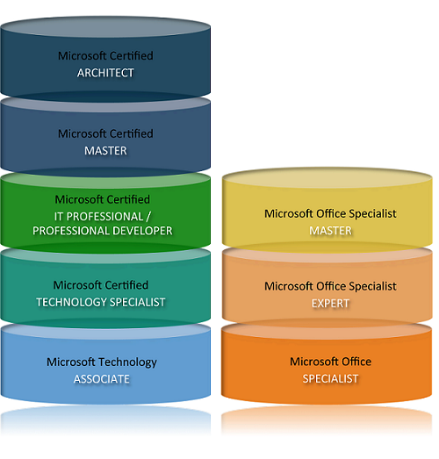

Technology professional
A range of Microsoft Certifications are available for IT professionals and developers of all skill levels—from entry-level positions to solution architects.
- Learn how to start your certification journey
- Explore certifications by technology
- Explore certifications by name

Business professional
If using Microsoft Office products is a vital part of your job, consider earning a Microsoft Office Specialist (MOS) certification.
- Learn how to start your certification journey
- Explore MOS certifications
- Explore free, self-paced training courses for Microsoft Office programs

Student
Microsoft Certifications can take you a long way in distinguishing yourself from others who may be competing for the same job. Being Microsoft-certified helps increase your employability and academic success. Numerous Microsoft Certifications are accredited and recommended for college credit.
High school, college, and university students enrolled full-time or part-time in a degree or diploma program can receive a discount of up to 55 percent off the retail price of Microsoft Certified Technology Specialist (MCTS) certifications. Discounts are also available on select Microsoft Certified IT Professional (MCITP) and Microsoft Certified Professional Developer (MCPD) certifications.
- Learn about MCTS certifications
- Learn about MCITP certifications
- Learn about MCPD certifications

Training
Featured courses: Make the switch to Office 2010

  Make the switch to  Excel 2010 |   Make the switch to  Word 2010 |   Make the switch to  Outlook 2010

  Make the switch to  Access 2010 |   Make the switch to  PowerPoint 2010 | 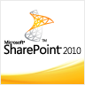  Make the switch to  SharePoint 2010

Office 2010 training
Access 2010  Excel 2010  OneNote 2010 | Outlook 2010  PowerPoint 2010  Project 2010 | Visio 2010  Word 2010

Office 2007 training
Access 2007  Excel 2007 | OneNote 2007  Outlook 2007  PowerPoint 2007  Project 2007 | Visio 2007  Word 2007

Office 2003 training
Access 2003  Excel 2003  FrontPage 2003  InfoPath 2003 | OneNote 2003  Outlook 2003  PowerPoint 2003  Project 2003 | Publisher 2003  Visio 2003  Word 2003

